HTML Heading Elements

📘 Definition
# Source: AI Source: Provided by: [Data Path: Persons Table -> ID Column: 1, Name_En Column: Motasem Essam] -> From: [ChatGPT] on [5/6/2026]
HTML heading elements are used to define titles and subtitles on a webpage.
They help organize content from:
- largest heading → smallest heading

🔢 HTML Heading Tags
# Source: AI Source: Provided by: [Data Path: Persons Table -> ID Column: 1, Name_En Column: Motasem Essam] -> From: [ChatGPT] on [5/6/2026]
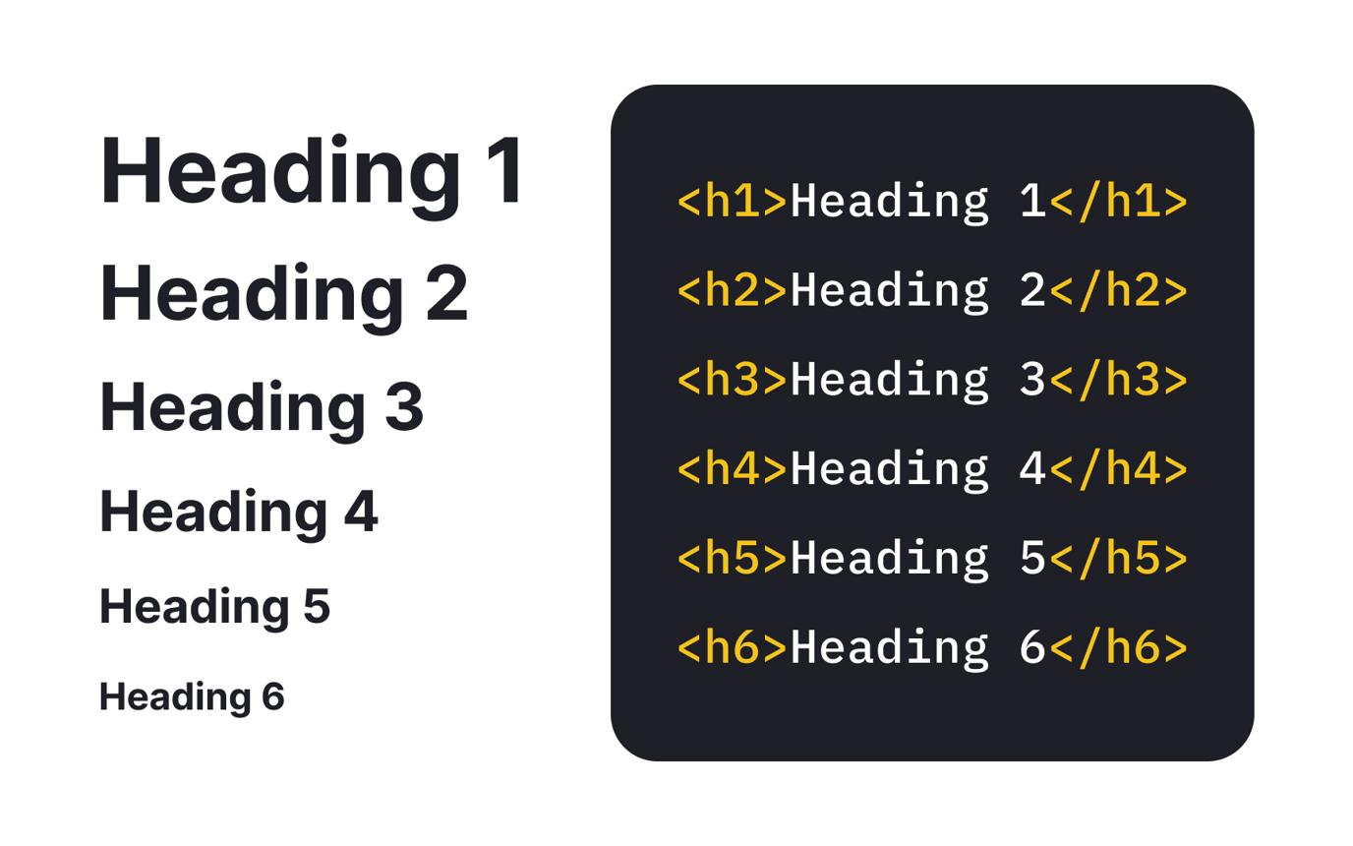
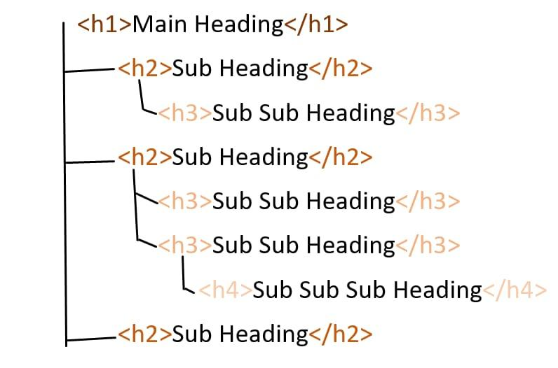
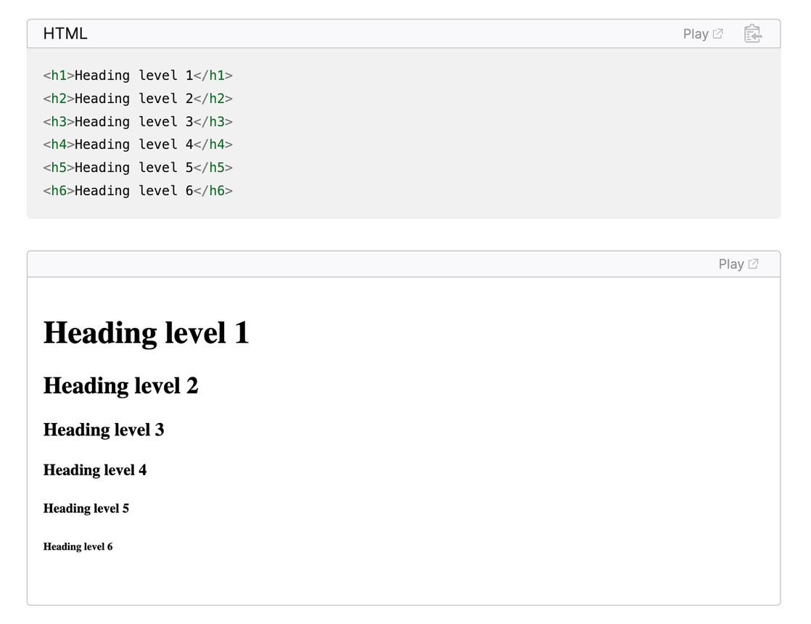
HTML provides 6 heading levels:
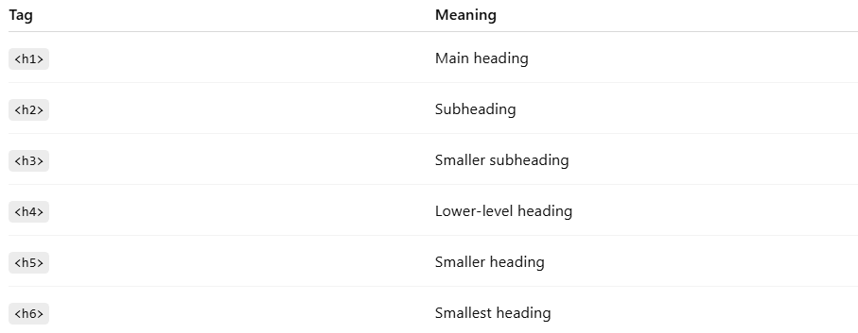
Tag | Meaning
<h1> | Main heading
<h2> | Subheading
<h3> | Smaller subheading
<h4> | Lower-level heading
<h5> | Smaller heading
<h6> | Smallest heading

💻 Example

Full Example
# Source: AI Source: Provided by: [Data Path: Persons Table -> ID Column: 1, Name_En Column: Motasem Essam] -> From: [ChatGPT] on [5/6/2026]
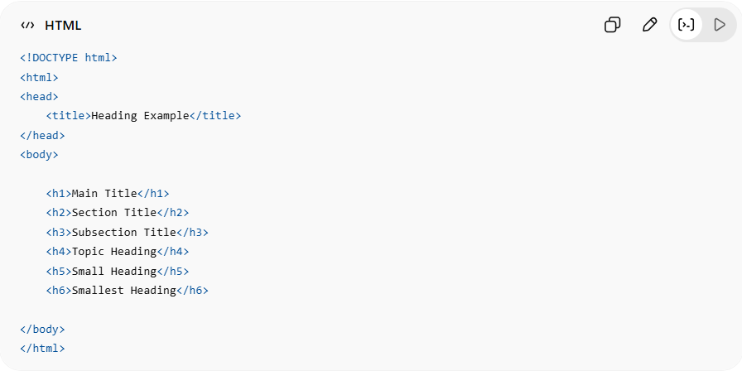
<!DOCTYPE html>
<html>
<head>
<title>Heading Example</title>
</head>
<body>
<h1>Main Title</h1>
<h2>Section Title</h2>
<h3>Subsection Title</h3>
<h4>Topic Heading</h4>
<h5>Small Heading</h5>
<h6>Smallest Heading</h6>
</body>
</html>

Real Example
# Source: ScreenShot Source: Provided by: [Persons Table -> ID Column: 1, Name_En Column: Motasem Essam] -> Tool: [Automation Table -> ID Column: 16, Name_En Column: Screen Capture] -> From [Operating System: Windows] on [5/6/2026]
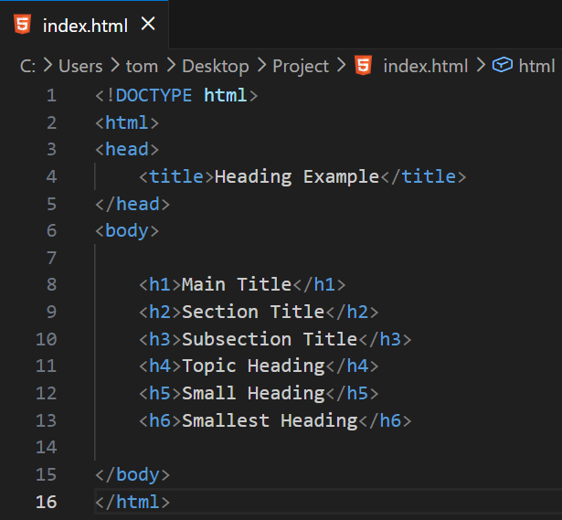
<!DOCTYPE html>
<html>
<head>
<title>Heading Example</title>
</head>
<body>
<h1>Main Title</h1>
<h2>Section Title</h2>
<h3>Subsection Title</h3>
<h4>Topic Heading</h4>
<h5>Small Heading</h5>
<h6>Smallest Heading</h6>
</body>
</html>
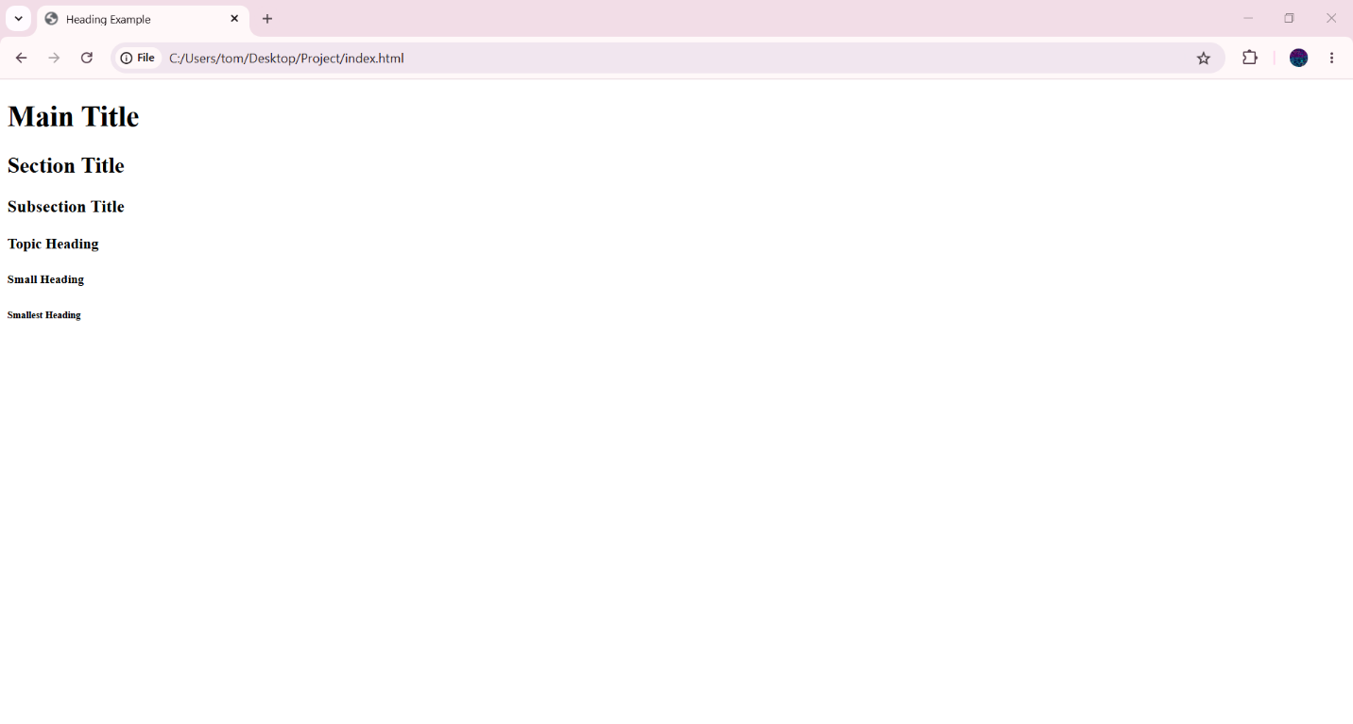

🧠 How Headings Work
# Source: AI Source: Provided by: [Data Path: Persons Table -> ID Column: 1, Name_En Column: Motasem Essam] -> From: [ChatGPT] on [5/6/2026]
- <h1> → most important heading
- <h6> → least important heading
Browsers automatically make:
- larger headings bigger and bolder
- smaller headings less prominent

🌐 Why Headings are Important
# Source: AI Source: Provided by: [Data Path: Persons Table -> ID Column: 1, Name_En Column: Motasem Essam] -> From: [ChatGPT] on [5/6/2026]
📖 1. Organize Content
Makes webpages easier to read.
🔍 2. Improve SEO
Search engines use headings to understand page structure.
♿ 3. Accessibility
Screen readers use headings for navigation.

⚠️ Best Practices
# Source: AI Source: Provided by: [Data Path: Persons Table -> ID Column: 1, Name_En Column: Motasem Essam] -> From: [ChatGPT] on [5/6/2026]
✅ Use one <h1> per page
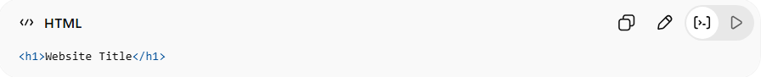
<h1>Website Title</h1>
✅ Keep proper order
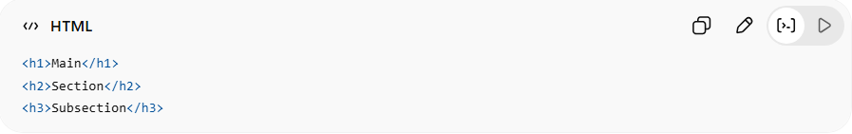
<h1>Main</h1>
<h2>Section</h2>
<h3>Subsection</h3>
❌ Bad Practice
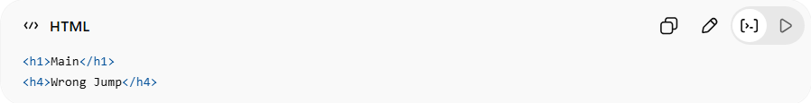
<h1>Main</h1>
<h4>Wrong Jump</h4>
👉 Avoid skipping heading levels unnecessarily

🚀 In short:
# Source: AI Source: Provided by: [Data Path: Persons Table -> ID Column: 1, Name_En Column: Motasem Essam] -> From: [ChatGPT] on [5/6/2026]
HTML heading elements (<h1> → <h6>) are used to create titles and organize webpage content hierarchically.

